**Assignment 4 – Animated Data Visualization**

**Question 1:**

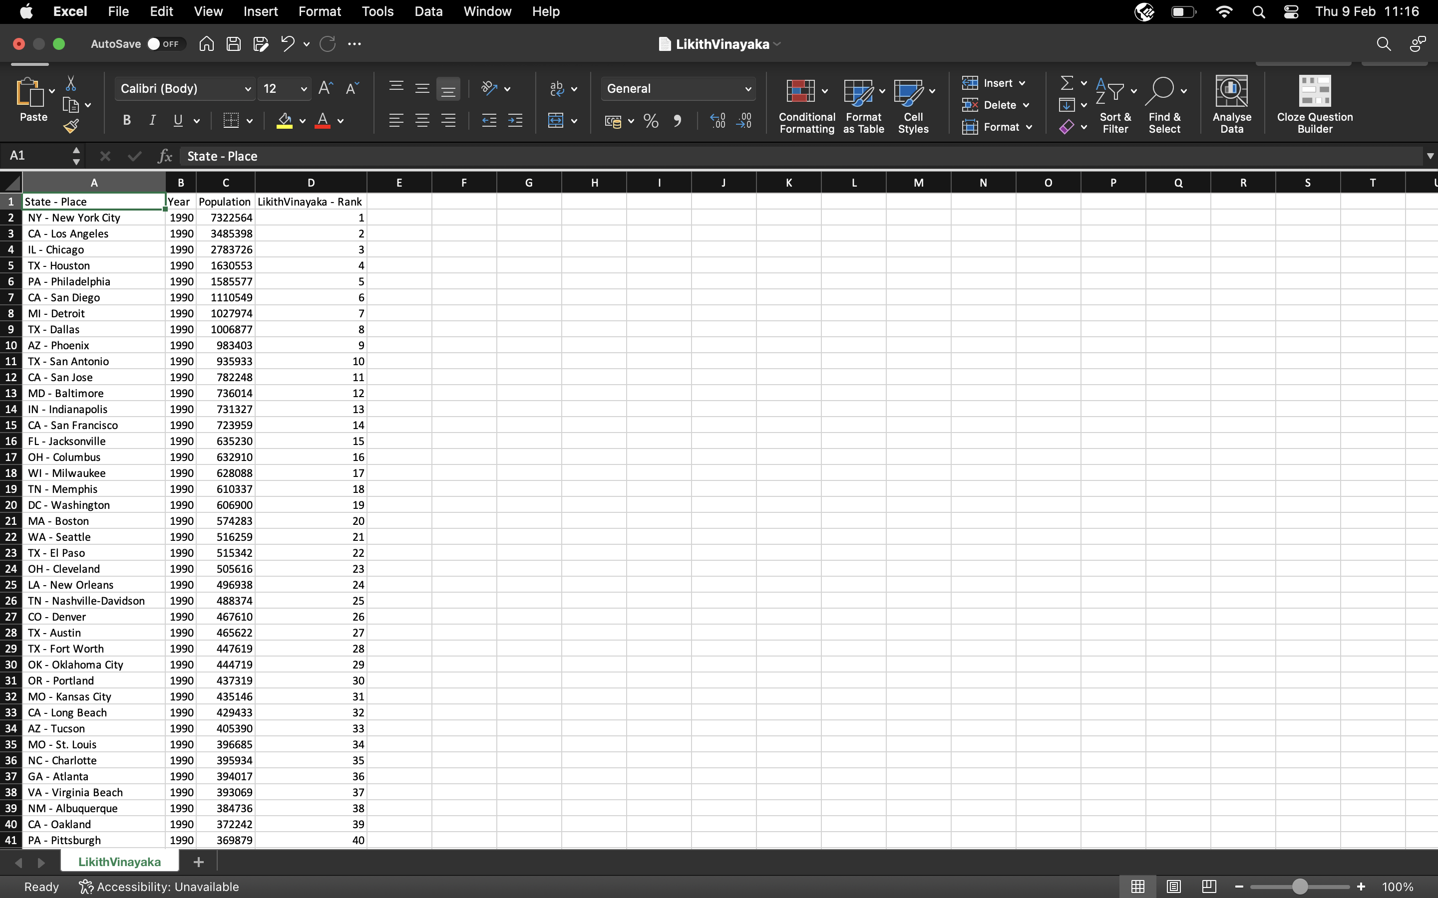

**Question 2:**

**Question 3:**

**Question 4:**

**Question 5:**

**Question 6:**

